Nama : Adridinan Najmi Faza
NIM : H1D025059
Shift Awal/Akhir : B/H

A. Buatlah query sebagai Berikut

Join 2 Table clause where
SELECT
-> a.cust_name,
-> b.order_num,
-> b.order_date
-> FROM
-> customers a,
-> orders b
-> WHERE
-> a.cust_id = b.cust_id;
4 rows in set (0.001 sec)
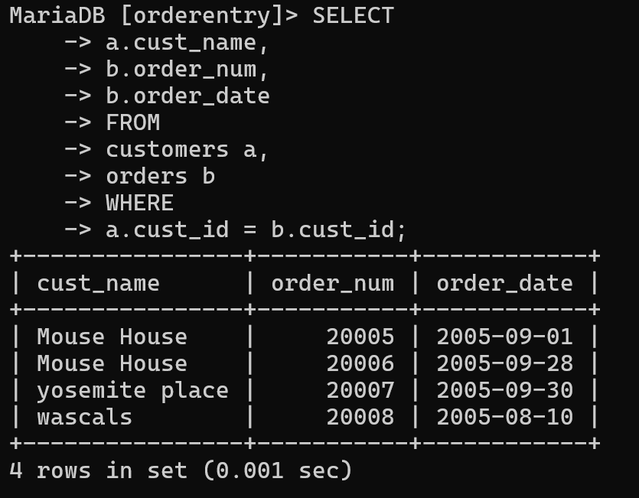

Query dengan join on dari 3 tabel
MariaDB [orderentry]> SELECT
-> a.cust_name,
-> b.order_date,
-> c.quantitiy
-> FROM
-> customers a,
-> orders b,
-> orderitems c
-> WHERE
-> a.cust_id = b.cust_id and
-> b.order_num = c.order_num;
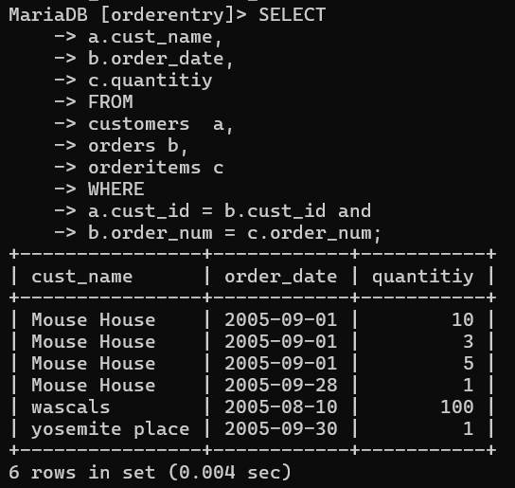

Right Join
MariaDB [orderentry]> select a.cust_name, b.order_num, b.order_date from customers a right join orders b on a.cust_id=b.cust_id;
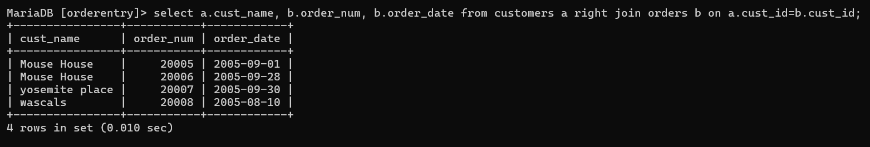

Left Join
MariaDB [orderentry]> select a.cust_name, b.order_num, b.order_date from customers a left join orders b on a.cust_id=b.cust_id;
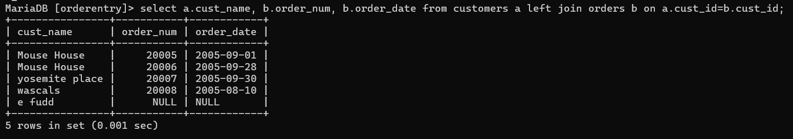

Self Join
MariaDB [orderentry]> select a. vend_name, b. vend_state, 'Negaranya', b.vend_country from vendors a inner join vendors b on a.vend_id=b.vend_id;
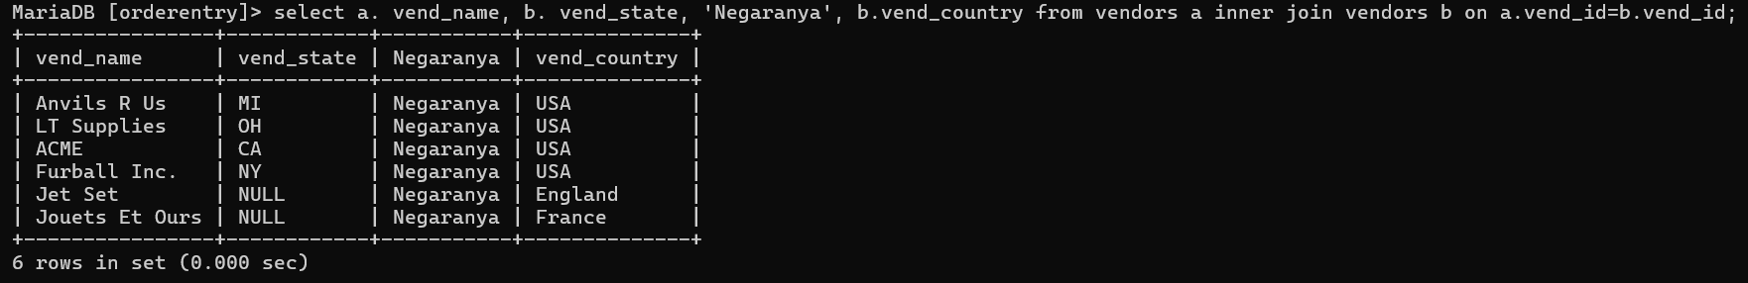

View
MariaDB [orderentry]> CREATE VIEW najmijoin AS
MariaDB [orderentry]> CREATE VIEW najmijoin AS
-> SELECT
-> a.cust_name,
-> b.order_date,
-> c.quantitiy
-> FROM
-> customers a
-> JOIN
-> orders b ON a.cust_id = b.cust_id
-> JOIN
-> orderitems c ON b.order_num = c.order_num;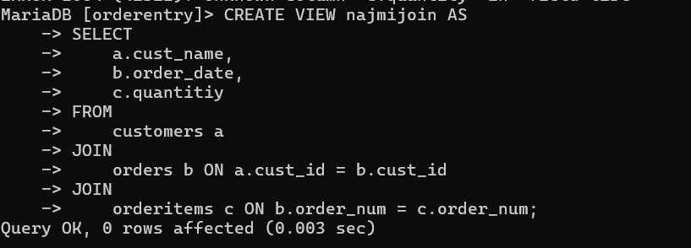

Buatlah triger after delete untuk salah satu table di order entry. Serta tunjukkan hasil akibat penerapan trigger.

Membuat tabel (trash bin)
MariaDB [orderentry]> create table producnotes_hapus as select*from productnotes where 1=2; Query OK, 0 rows affected (0.013 sec) Records: 0 Duplicates: 0 Warnings: 0
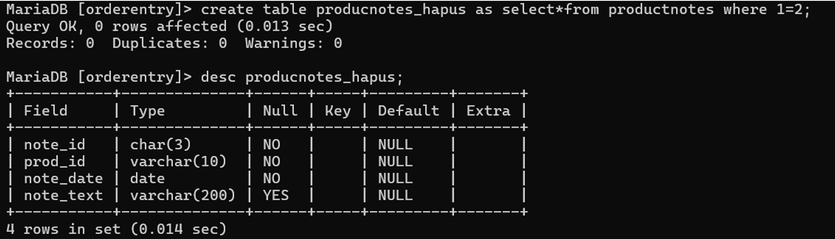

Tambahkan field
Tambahkan kolom tgl_hapus dan user untuk merekam kapan data dihapus dan siapa yang menghapus
MariaDB [orderentry]> desc productnotes_hapus;
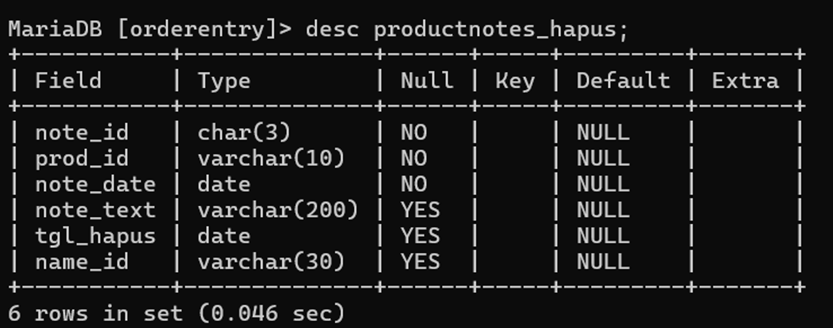

Membuat trigger untuk eksekusi jika terjadi penghapusan pada tabel
MariaDB [orderentry]> DELIMITER $$
MariaDB [orderentry]>
CREATE TRIGGER productnotes_hapus after delete
-> ON productnotes for each row
-> BEGIN
-> INSERT INTO productnotes_hapus
-> ( note_id,
-> prod_id,
-> note_date,
-> note_text,
-> tgl_hapus,
-> name_id
-> )
-> VALUES
-> ( OLD.note_id,
-> OLD.prod_id,
-> OLD.note_date,
-> OLD.note_text,
-> SYSDATE(),
-> CURRENT_USER
-> ); -> end $$ Query OK, 0 rows affected (0.051 sec)
MariaDB [orderentry]> DELIMITER ;
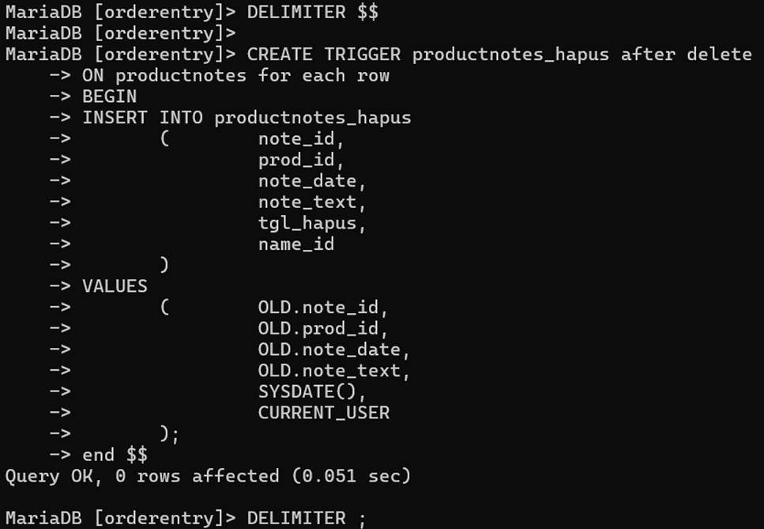

Deskripsikan tabel (trashbin) yang udah dibuat sebelumnya
MariaDB [orderentry]> desc productnotes_hapus;
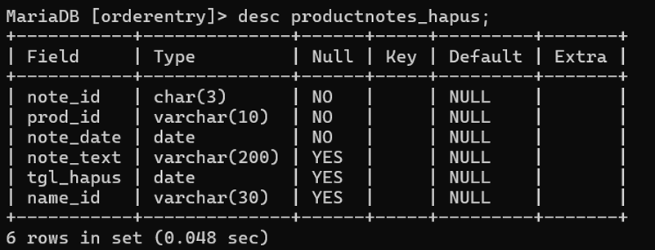

Tampilkan data yang berada dalam tabel productnotes
MariaDB [orderentry]> select*from productnotes;
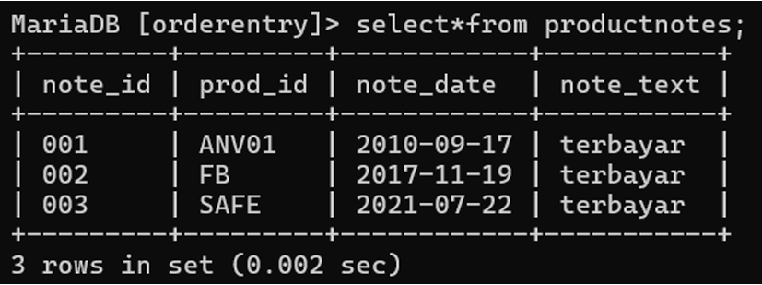

Hapus salah satu row dari tabel productnotes dan buka tabel untuk memastikan bawa data sudah memang terhapus
MariaDB [orderentry]> delete from productnotes where note_id='002'; Query OK, 1 row affected (0.046 sec) MariaDB [orderentry]> select*from productnotes;
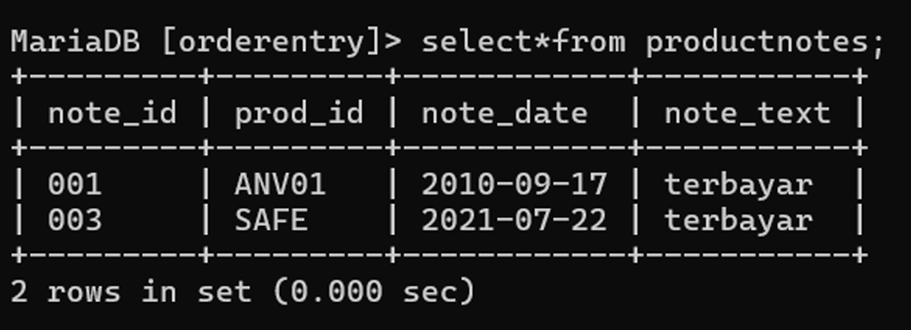

Tampilkan tabel productnotes_hapus untuk melihat data dari productnotes yang sudah dihapus
MariaDB [orderentry]> select*from productnotes_hapus;
